**Setting AGT+ roulette ball sensor**

On the top of the roulette wheel there is an infra red diode (see Fig. 1) that is shining down, through the little holes on the ball sensor – infra red receiver (see Fig. 2). On the main sensor board there is a signal light D5 (see Fig. 3) - ussualy green color, that indicates receiver's signal – for every hole signal light flashes. If there is a ball on the roulette wheel, signal light flashes all the time, except when the ball passes the position of ball sensor. Ball covers the hole, so IR diode light is not coming to ball sensor receiver.

You can move ball sensor up and down to make an ideal position. The roulette wheeel must spining all the time. If ball sensor is too much up or down, D5 signal light is not flashing. Ideal position is in the middle. Unscrew ball sensor screwes to move ball sensor up and down. Ball sensor can be damaged by rotating wheel - don't push it too much up during the wheel rotation.

Fig. 1 – Bal sensor

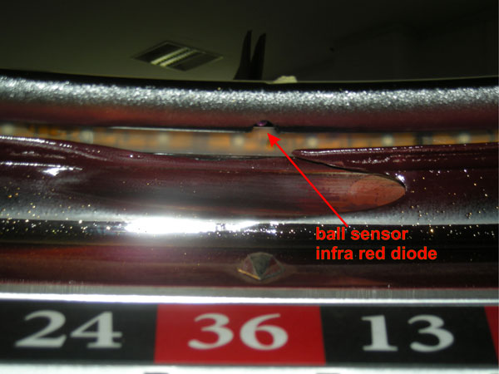

Fig. 2 – Device Manager

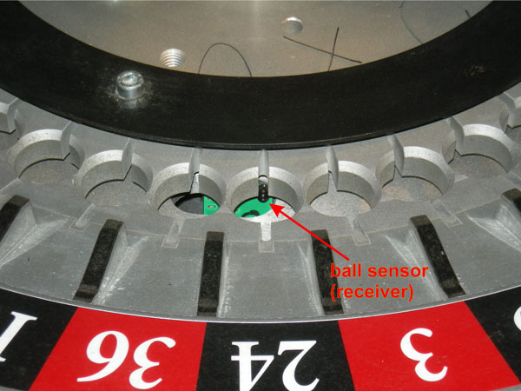

Fig. 3 – Terminal calibration

