**Calibrating AGT+ roulette ball sensor**

There is an USB connector (see Fig. 1) on the main sensor board. It must be connected to the winXP PC computer – e.g. your notebook. New USB serial port is shown in Device manager when you plug in main sensor (see Fig. 2). Use Ftdi4 drivers if computer asks.

Use AGT+ Term program ( or any other terminal at speed 115200 bps ) to connect and comunicate with main sensor board (see Fig 3). With AGT+ Term program choose right COM port and communication speed 115200. Click Alt+X button for indicator light to go from red to green. In blue area of Term you can write commands now – e.g. help, followed by enter. Sensor main board must respond.

To calibrate sensors:

* Roulette wheel must rotating
* Ball must running around the cylinder – over the rim sensors
* In Term program write »calibrate –v –a« and press enter. Program waits 5 seconds and write something like you see on Fig. 3.
* In Term program write »calibrate -S« and press enter to save the setings. Use CAPITAL »S«.

Response:

calibrate: wait 5s ... c1(x): 0 122 c2(x): 0 123 ho(x): 12 134 [OK]

c1: rim sensor 1

c2: rim sensor 2

ho: ball sensor

(x): means that calibration was sucessfull

First number of c1 and c2 sensors must be 0 or not over 50.

Second number of c1 and c2 sensors must be around 122, but not lower than 100

First number of ho sensor must be around 12, not more than 50

Second number of ho sensor must be around 134, but not lower than 100

First time you run AGT+ program on WinXP computer, run term\RunMeOnec.bat.

Fig. 1 – Bal sensor

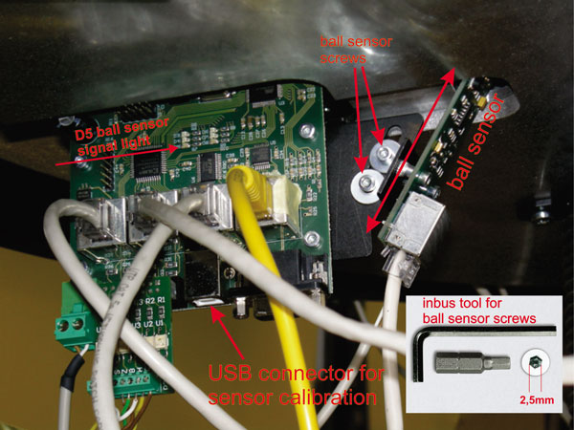

Fig. 2 – Device Manager

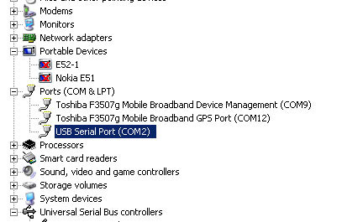

Fig. 3 – Terminal calibration

